Impaired overload-induced hypertrophy in obese Zucker rat slow-twitch skeletal muscle
Kim, Han Kook·Hong, Kil Dong
Korea University
Abstract
Kim, Han-Kook, Hong, Kil-Dong. Impaired overload-induced hypertrophy in obese Zucker rat slow-twitch skeletal muscle. Exercise Science, 23(2): 000-000. 2014. The effect of insulin resistance(IR) on the adaptation of skeletal muscle loading is not well understood. Here we examine whether the soleus muscles of the lean Zucker(LZ) and insulin-resistant obese Zucker(OZ) rat exhibit differences in their ability to undergo muscle hypertrophy following 8 wk of mechanical overload. Four-week-old male LZ(n=5) and OZ(n=5) rats underwent unilateral surgical ablation of the gastrocnemius muscle while the contralateral hindlimb was used as an internal control. Mechanical overload increased soleus muscle wet weight(LZ 57 % and OZ 33 %, respectively; p<0.05) and average type 1 fiber cross-sectional area(LZ 32 % and OZ 5 %, respectively; p<0.05) in LZ and OZ rats, while the magnitude of these increases was greater in the LZ animals (p<0.05). The reduced degree of muscle hypertrophy observed in the OZ animals was associated with decreases in the ability of the OZ soleus muscle to phosphorylate p70s6k^{Thr 389} and mTOR, while phosphorylation of p70s6k^{Thr 389} was increased in the LZ overloaded soleus by 83 %(p<0.05). The amount of Tuberin/TSC2 phosphorylation, an inhibitor of mTOR, was unchanged in the LZ soleus after overload while it was increased(68.3 %, p<0.05) in OZ animals. Conversely, AMPK phosphorylation was decreased in the LZ(−22.77 %, p<0.05) but increased(57 %, p<0.05) in the OZ soleus with overload. Taken together, these data suggest that IR or other related comorbidities may impair the ability of the soleus to activate mTOR signaling and undergo load-induced muscle hypertrophy.
Key words : soleus, insulin resistance, muscle adaptation
Ⅰ. Introduction
Insulin resistance(IR) and the development of type 2(non-insulin dependent) diabetes mellitus(DM) is an emerging epidemic in Western cultures that is thought to afflict over 180 million people worldwide(Burke ＆ Hawley, 1999). Although exercise is commonly prescribed for the treatment of these disorders, relatively little is known regarding how IR may affect muscle adaptation. The beneficial effects of exercise on muscle are thought to be mediated through the activation of various signaling cascades involved in regulating changes in gene expression. Because skeletal muscle is a primary site of glucose disposal it is likely that modalities designed to increase muscle mass may be particularly beneficial for the treatment of IR(Newsholm, 1993; Kreider, 1999). How IR may affect the potential of skeletal muscle to undergo muscle hypertrophy is not well understood. Recent studies have suggested that differences may or may not exist between normal and IR muscle in their adaptation to an exercise regimen. Work from our laboratory using the IR obese Zucker(fa/fa) rat has suggested that IR may impair the ability of the skeletal muscle to activate mitogen activated protein kinase(MAPK) signaling in response to a bout of increased muscle loading. Although this study did not look at phenotypic adaptation, it nonetheless is consistent with the notion that IR affects the load-induced muscle signaling(Rowsell et al., 2009).
Shunaise & Cunnise(1990) have suggested that increased muscle loading correlates with increases in the rate of protein synthesis. One critical signaling pathway controlling protein synthesis during mechanically induced skeletal muscle growth involves mammalian target of rapamycin(mTOR) and its downstream protein p70 ribosomal protein S6 kinase(p70s6k). Previous studies have implicated mTOR in the muscle adaptation to increased contractile loading(Hemming et al., 2000; Hinds 2004; Mori et al., 2004). Hemming et al.(2000) reported that p70s6k lies downstream of mTOR and its activation leads to hyperphosphorylation of the ribosomal protein, S6, enabling the upregulation of 5´-TOP mRNA for encoding translational machinery and ribosomal proteins. mTOR/p70s6k signaling is thought to be negatively regulated by AMPK and Tuberin/TSC2, and recent data suggested that higher phosphorylation of AMPK and Tuberin/TSC2 are associated with decreased muscle protein synthesis(Brander et al., 1996; Eston ＆ Daniel, 1999; Rowsell et al., 2009).
The purpose of this study was to determine if IR affects the potential of skeletal muscle to undergo muscle hypertrophy. On the basis of our previous work demonstrating differences in muscle MAPK regulation with IR and other studies demonstrating alterations in the adaption of IR muscle to exercise, we hypothesized that IR muscle would exhibit a diminished ability to undergo skeletal muscle hypertrophy. To test this possibility, we subjected the soleus muscles of obese Zucker(OZ) and lean Zucker(LZ) rats to 8 wk of mechanical overload. Our data suggests that IR or other comorbidities may be associated with decreases in the ability of the soleus muscle to undergo muscle hypertrophy and that this alteration might be associated with differences in the activation of signaling pathways involved in regulating protein synthesis. Taken together, these results indicate that IR or other related comorbidities may affect how the soleus muscle adapts to an overload stimulus.
Ⅱ. Methods
1. Subjects
All procedures were performed as outlined in the "Guide for the Care and Use of Laboratory Animals” as approved by the Council of the American Physiological Society and the Animal Use Review Board of Marshall University. Young(4 wk, n=5) male lean Zucker and young(4 wk, n=5) male obese Zucker rats were obtained from the Charles River Laboratories. Rats were housed two per cage in an American Association for Accreditation of Laboratory Animal Care approved vivarium. Housing conditions consisted of a 12:12-h dark/light cycle and temperature was maintained at 22±2 ℃. Animals were provided food and water ad libitum and allowed to recover from shipment for at least 2 wk before experimentation. During this time the animals were carefully observed and weighed weekly to ensure that none exhibited signs of failure to thrive, such as precipitous weight loss, disinterest in the environment, or unexpected gait alterations.
2. Materials
Anti-p70S6k(#9202), mTOR(#2972), TSC2(#3612), Raptor(#4978), AMPK(#2532), phosphorylated p70S6K^{Thr389} (#9206), phosphorylated mTOR^{Ser2448}(#2971), phosphorylated TSC2^{Thr1462}(#3617), phosphorylated AMPK^{Thr172} (#2535), Mouse IgG(#7076), and Rabbit IgG(#7074) antibodies were purchased from Cell Signaling Technology(Beverly, MA). ECL Western blotting detection reagent was obtained from Amersham Biosciences(Piscataway, NJ). Restore Western blot stripping buffer was obtained from Pierce(Rockford, IL) and 3T3 cell lysates were from Santa Cruz Biotechnology(Santa Cruz, CA). All other chemicals were purchased from Sigma(St. Louis, MO) or Fisher Scientific(Hanover, IL).

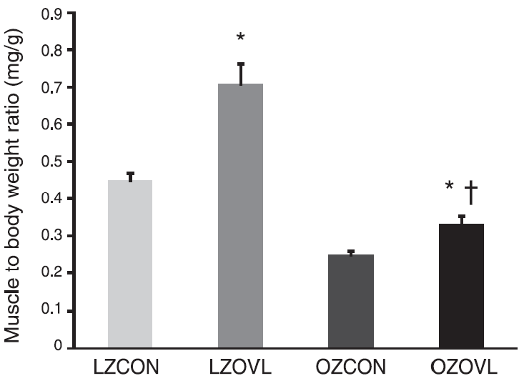
Fig. 1. Soleus muscle weight-to-body weight ratio of lean Zucker and obese Zucker control(LZCON; OZCON) and overloaded(LZOVL; OZOVL) rats. Values are means±SE; n=5. *Significant effect of OVL, p<0.05. †Significant difference from LZ. p<0.05.
3. Procedures
1) Surgical procedures
Rats were anesthetized with a ketamine-xylazine cocktail(50 mg/kg ip) and supplemented as necessary for reflexive response. In a sterile aseptic environment, the dorsal surface of the hindlimb was shaved and cleaned, and the superficial musculature was exposed by means of a proximal-to-distal incision through the skin and blunt separation of the skin and fasciae. The medial gastrocnemius and the proximal two-thirds of the lateral head of the gastrocnemius of the left hindlimb were carefully isolated by blunt manipulation of the tissues and were removed.
2) Tissue isolation
Animals were anesthetized with a ketamine-xylazine(4:1) cocktail(50 mg/kg intraperitoneal injection) and supplemented as necessary for reflexive response. Soleus muscles were quickly removed, blotted dry, weighed, and immediately frozen in liquid nitrogen. Tissues were stored at -80 ℃ until use.
3) Measurement of fiber cross-sectional area
Prior to biochemical processing, muscles were cut into thirds with the middle segment reserved for histological analysis. After flash freezing in liquid N2 muscles were sectioned(8 ㎛) in a cryostat at -20 ℃. Tissue sections were collected on poly-lysine-coated microscopic slides (Superfrost, Fisher Scientific) and histochemically reacted for myofibrillar ATPase activity after alkaline(pH 9.4) preincubation as previously outlined.
4. Statistics
Results are presented as means±SE. Data were analyzed by using the Sigma Stat 3.0 statistical program. Differences were determined using a two-way ANOVA followed by Student-Newman-Keuls post hoc testing when appropriate. p<0.05 was considered to be statistically significant.
Ⅲ. Results
1. IR decreases soleus muscle hypertrophy
Over the 8 wk mechanical overload period, the average body mass of OZ rats was 54 % greater than lean counterparts(LZ 414±15 vs. OZ 651±22 g; p<0.05). Compared with lean animals, soleus muscle mass was 12 % less(LZ 186±8 vs. OZ 163±8 mg) in the OZ rats. Eight weeks of synergistic ablation increased the soleus mass-to-body weight ratio of the LZ and OZ by 58 and 33 %, respectively (p<0.05; Fig. 1). Similarly, overload increased
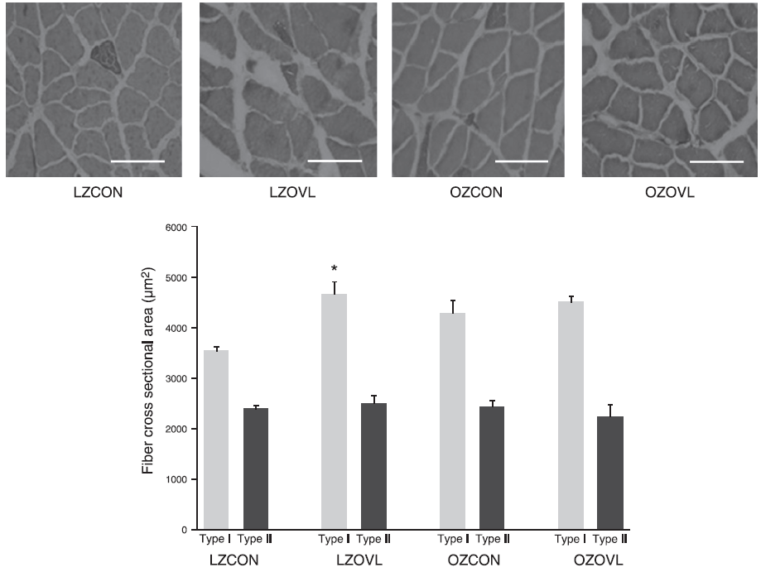
Fig. 2. Representative ATPase stained cross sections of soleus muscle of LZ and OZ CON and OVL rats. Type 1 and type 2 fiber cross sectional areas of LZCON and OZCON and LZOVL and OZOVL rats. Values are means±SE; n=5. *Significant effect of OVL, p<0.05. (Scale bar=100 ㎛).
type I fiber CSA to a greater extent in the LZ (32 %; 3,540±236 vs. 4,664±710 ㎛²; p<0.05), whereas a similar increase is not observed in the OZ animals and in type 2 fibers (p>0.05; Fig. 2). Taken together, these data demonstrate that the hypertrophic response of the soleus differed between animal models.
2. IR affects overload-induced signaling in the soleus
To examine the role of p70s6k in overload-induced muscle hypertrophy, p-p70s6k^{Thr 389} and total p70s6k levels were compared in control and overloaded soleus muscles of either group. Levels of total p70s6k protein were decreased(p<0.05) with overload in the OZ soleus(Fig. 3). Levels of phosphor p70s6k^{Thr 389} protein were increased by 83 %(p<0.05) in the LZ soleus in response to overload, while it was decreased by 54 %,(p<0.05) in the OZ soleus(Fig. 3). Levels of phosphor p70s6k^{Thr 389} protein were 58 % lower in the overloaded IR muscle compared with the overloaded LZ soleus(p<0.05).
Ⅳ. Discussion
The obese Zucker(fa/fa) rat is a well established animal model of skeletal muscle IR that is characterized by marked hyperinsulinemia, glucose intolerance, dyslipidemia, and central adiposity(Newsholm, 1993; Kreider, 1999). The intent of this study was to determine whether the slow-twitch soleus muscles of normal and IR rats exhibit a similar degree of adaptation to muscle overload induced by surgical ablation of synergistic muscles. The primary finding of this study is our demonstration that IR may diminish the ability of slow muscle to undergo overload-induced muscle hypertrophy and that this finding appears to be associated with alterations in the activation of intramuscular signaling cascades.
Table 1. Relative expression levels of total, phosphor p70s6k^{Thr389}, total and phosphor mTOR^{ser2448} in soleus muscles
 | LZCON | LZOL | OZCON | OZOL | F | P
p70s6k | 1.00±0.0 | 1.23±0.31 | 1.21±0.18 | 1.23±0.25 | 23.5 | 0.013
p-p70s6k^{Thr389} | 1.00±0.0 | 1.32±0.25 | 1.13±0.019 | 1.09±0.14 | 21.0 | 0.031
Total mTOR | 1.00±0.0 | 1.15±0.54 | 1.25±0.10 | 1.32±0.13 | 18.5 | 0.037
p- mTOR^{ser2448} | 1.00±0.0 | 1.31±0.23 | 1.32±0.13 | 1.39±0.19 | 19.5 | 0.028
Values are means±SE; n=5, *Significant effect of OVL, p<0.05
Muscle adaptation to overload is typically characterized by increases in muscle mass and muscle CSA. We observed similar findings in the both animal models; however, the magnitude of overload-induced changes was attenuated in the IR OZ animals. Why the degree of muscle adaptation was less in the OZ animals is not readily clear. It is possible that increasing the length of the ablation stimulus would have normalized the degree of adaptation between the animal models since previous data have shown that muscle adaptation to synergistic ablation appears to continue unabated even after 30 days of overload(Green et al., 2000).
Because the hypertrophy stimulus in the synergistic ablation model is dependent, at least in part, on animal activity it is also possible that differences in the degree of adaptation between models could be related to differences in animal activity, obesity, and/or other associated comorbidities. Indeed, previous reports have demonstrated that the OZ rat is significantly less active than the LZ rat(Longworth, 1982). Nonetheless, it should be noted that the greater body mass of the OZ rats should have produced a greater overload stimulus for muscle growth on the weight-bearing muscles. As such, we consider it unlikely that the differences in muscle adaptation we observe are due to differences in the overload stimulus. Future research using other IR models that do not exhibit differences in animal activity or alterations in body weight will certainly be useful in determining if the differences in muscle adaptation we observe are due to factors intrinsic to the muscle or are a byproduct of the experimental model.(Labyak et al., 1997).
Previous reports have demonstrated that increases in muscle protein synthesis following an increase in muscle loading are thought to be regulated, at least in part, by the phosphorylation of p70s6k(Straburzynska-Lupa et al., 2007). Here we report that the magnitude of the overload-induced phosphorylation of p70s6k^{Thr 389} appears to be significantly different in the IR soleus muscle compared with that observed in the normal soleus (Fig. 3). To our knowledge, this finding has not been reported before. The underlying molecular mechanism(s) for this alteration remains unclear; however, it is interesting to note that other studies have demonstrated that the insulin-stimulated phosphorylation of p70s6k may be altered in the diabetic rat model(Wozniak et al., 2007). In the light of these studies, our data suggest that IR may affect how multiple stimuli may regulate the phosphorylation of p70s6k. Future studies designed to examine if IR affects the regulation of p70s6k using different overload models or muscles with different muscle fiber types will no doubt be useful in furthering our understanding of the effects of IR on p70S6k activation.
Ⅴ. Conclusion
In summary, the data of the present study suggest that IR and other related comorbidities may be associated with a decrease in the ability of the soleus muscle to adapt to a strong hypertrophic stimulus. Our findings suggest that this difference in muscle hypertrophy may be related to differences between models in the activation of mTOR, TSC2, raptor, AMPK, and p70S6k signaling. Although this possibility is promising it should be noted that the functional role of these molecules in regulating muscle hypertrophy cannot be accurately assessed in the absence of further study to evaluate experimental manipulation of this protein. Additional studies perhaps employing strategies designed to directly inhibit or activate these signaling molecules during mechanical overload may prove to be useful in addressing this possibility. Irrespective of the mechanism, it is likely that IR or related comorbidity associated differences in the ability of skeletal muscle to undergo hypertrophy may be of clinical importance given the potential role that muscle growth may play in regulating glucose homeostasis.
References
Anders, D. G., Kerry, J. A., & Pari, G. S. (2007). CMV DNA Synthesis and Late Viral Gene Expression. In A. Arvin, G. Campadelli-Fiume, E. Mocarski, P. S. Moore, B. Roizman, R. Whitley, & K. Yamanishi (Eds.), Human Herpesviruses: Biology, Therapy, and Immunoprophylaxis (pp. 295-310). Cambridge: Ca-mbridge University Press.
Banfi G., ＆ Melegati G. (2008). Effect on sport hemolysis of cold water leg immersion in athletes after training sessions. Lab. Hematol., 14(2): 15-18.
Banfi G., Melegati G., Barassi A., Doglitti, G., Melzidi'Eril, G. et al. (2009). Effects of whole-body cryotherapy on serum mediators of inflammation and serum muscle enzymes in athletes. J. Thermal Biol., 34(2): 55-59.
Banfi G., Lombardi G., Colombini, A., ＆ Melegati G. (2010). Whole-body cryotherapy in athletes. Sports Med., 40(6): 509-617.
Black C., Vickerson B., ＆ McCully K. (2003). Noninvasive assessment of vascular function in the posterior tibial artery of healthy humans. Dyn. Med., 2(1): 35-42.
Brandner, B., Munro, B., Bromby, L. M., ＆ Hetreed, M. (1996). Evaluation of the contribution to postoperative analgesia by local cooling of the wound. Anaesthesia, 51(11): 1021-1025.
Brooks, G. A., Dubouchaud, H., Brown, M., Sicurello, J. P., ＆ Butz, C. E. (1999). Role of mitochondrial lactic dehydrogenase and lactate oxidation in the "intra-cellular lactate shuttle." Proc. Natl. Acad. Sci., 96(16): 1129-1134.
Brooks, G., Fahey, T., & White, T. (1996). Exercise Physiology : Human Bioenergetics and Its Applications (2nd ed.). California: Mayfield publishing company. 540-543.
Burke L. M., ＆ Hawley J. A. (1999). Carbohydrate and exercise. Curr. Opin. Clin. Nutr. Care, 2(6): 515-520.
Clarkson, P. P. M., ＆ Sayers, S. P. (1999). Etiology of exercise-induced muscle damage, Can. J. Appl. Physiol., 24(3): 234-248.
Eston, R., & Peters, P. (1999). Effects of cold water immersion on the symptoms of exercise-induced muscle damage. J. Sports Sci., 7(3): 231-238.
Green, H. J., Burnett, M., Otto, C., Pipe, A., McKenzie, D. et al. (2000). Increase in submaximal cycling efficiency mediated by altitude acclimatization. J. Appl. Physiol., 89(3): 1189-1197.
Hemmings, B., Graydon, J., ＆ Dyson, R. (2000). Effects of massage on physiological restoration, perceived recovery, and repeated sports performance. Br. J. Sports Med., 34(2): 109-114.
Hernandez-Reif M., Field T., ＆ Krasnegor, J. (2001). Lower back pain is reduced and range of motion increased after massage therapy. Int. J. Neurosci., 106(3-4): 131-145.
Hinds, T., McEwan, I., Perkes, J., Dawson, E., Ball, D. et al. (2004). Effects of massage on limb and skin blood flow after quadriceps exercise. Med. Sci. Sports Exerc., 36(8): 1308-1313.
Kreider, R. B. (1999). Dietary supplements and the promotion of muscle growth with resistance exercise. Sports Med., 27(2): 97-110.
Labyak, S., ＆ Metzger, B. (1997). The effects of effleurage backrub on the physiological components of relaxation: a meta-analysis. Nurs. Res., 46(1): 59-62.
Leivadi, S., Hernandez-Rief, M., Field, T., O'Rourke, M., D'Arienzo, S. et al. (1999). Massage therapy and relaxation effects on university dance students. J. Dance Med. Sci., 3(3): 108-112.
Leppäluoto, J., Dugue, B., ＆ Mikkelsson, M. (2008). Effects of long-term whole-body cold exposures on plasma concentrations of ACTH, beta-endorphin, cortisol, catecholamines and cytokines in healthy females. Scand. J. Clin. Lab. Invest., 68(2): 145-153.
Lohman, T. G., Roche, A. F., & Martorell, R.(1992). Anthropometric standardization reference manual. Champaign, Illinois: Human Kinetics. 150-163.
Longworth, J. (1982). Psychophysiological effects of slow stroke back massage in normotensive females. Adv. Nurs. Sci., 4(4): 44-61.
Mitchell, B. J. C., ＆ Banister, E. W. (1990). Neural control of the circulation during exercise. Sports Sci., 22(2): 141-154.
Mori, H., Ohsawa, H., Tanaka, TH., Taniwaki, E., Leisman, G. et al. (2004). Effect of massage on blood flow and muscle fatigue following isometric lumbar exercise. Med. Sci. Monit., 10(5): 173-178.
Rowsell, G. J., Couutts, A. J., Reaburn, P., ＆ Hill-Haas, S. (2009). Effects of cold-water immersion on physical performance between successive matches in high-performance junior male soccer players. J. Sports Sci., 27(6): 565-573.
Schnase, J. L., & Cunnius, E. L. (Eds.). (1995). Proceedings from CSCL '95: The First International Conference on Computer Support for Collaborative Learning. Mahwah, NJ: Erlbaum.
Straburzynska-Lupa, A., Konarska, A., Nowak, A., Straburzynska-Migaj, E., Konarski, J. et al. (2007). Effect of whole-body cryotherapy on selected blood chemistry parameters in professional field hockey players [in Polish]. Fizjoterapia Polska, 7(1): 201-215.
Stringer, W., Casaburi, R., ＆ Sejersted, O. M. (1992). Acid-base regulation during exercise and recovery in humans. J. Appl. Physiol., 72(3): 954-961.
Wozniak, A., Wozniak, B., Drewa, G., Mila- Kierzenkowska, C., ＆ Rakowski, A. (2007). The effect of whole-body cryostimulation on lysosomal enzyme activity in kayakers during training. Eur. J. Appl. Physiol., 100(2): 137-142.
Submitted 2011. 08. 00
Received 2011. 00. 00
Accepted 2011. 00. 00

* Corresponding author : Hong, Gil Dong, Korea University, seonunge@naver.com

